# Capstone project: Sydney vs Melbourne

## Background

I live in Australia thus I want to perform a local case study using Foursquare location data.

Sydney and Melbourne are well-known to be the most famous cities in Australia, and these two cities are both proud of their cultural diversity. However, Sydney and Melbourne are competing in many aspects to show "this city" is the effective cultural capital of Australia.

Hence, in this capstone project, I would like to provide a little evidence that between Sydney and Melbourne, which is the city has a more diverse dining culture.

## Data description

To perform the case study, I introduced in the background section, I will choose the central parts of the two cities as the reference locations. Hence, I will choose to use 'Sydney Townhall' as the central point in Sydney, and use 'Melbourne Townhall' as the central point in Melbourne. The exploring radius will be set as 2.5km which is likely to cover the most active areas of the two cities.

The data will be used include:

1. Restaurant name;
2. Restaurant category;
3. Restaurant expense;
4. The number of tips for each restaurant.

## Exploring steps

1. Use the Foursquare agent to explore the restaurants around the two central points, will a limit of 200;
2. Compare how diverse these restaurants are in terms of styles (say Italian, French, Chinese...);
3. Compare how diverse these restaurants are in terms of expense level (say street food, cheap, medium, expensive, luxury);
4. Compare how popular these restaurants are in terms of the tips in the Foursquare location data.

## Restaurant map in Sydney and Melbourne

Category map for restaurants in central Sydney (Restaurant info list are attached in the appendix):

This section maps the obtained restaurants in a Folium map. Each colour corresponds to a restaurant category.

Clearly, there are many Chinese restaurants and they are located closely at the central area.

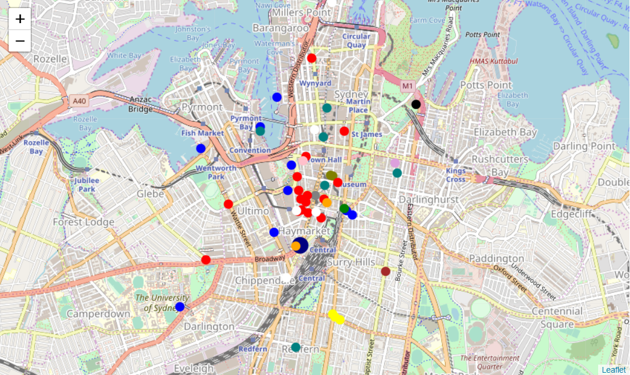

Figure 1 Restaurant category map in central Sydney

Category map for restaurants in central Melbourne (Restaurant info list are attached in the appendix):

It seems there are more Australian style restaurants in central Melbourne (compare to those in central Sydney).

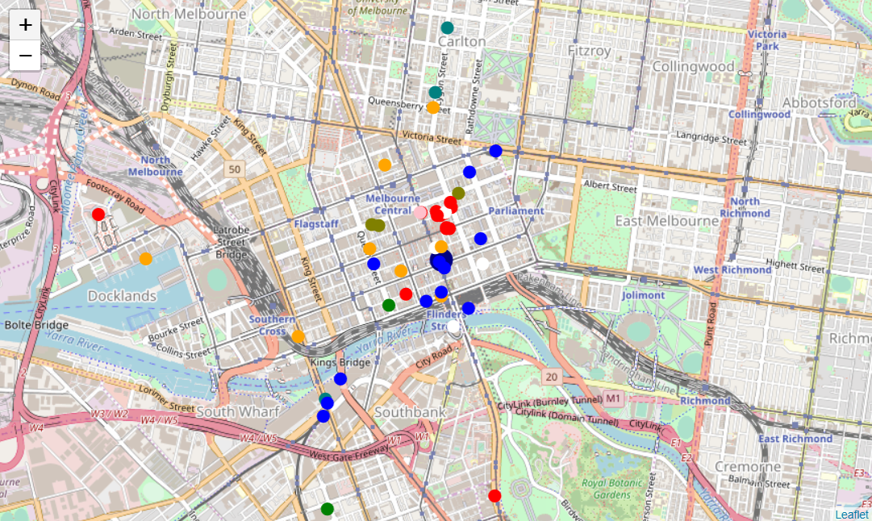

Figure 2 Restaurant category map in central Melbourne

## Results and discussion

### Top 5 restaurant categories

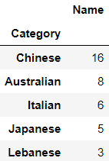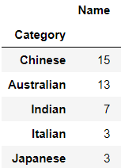

Figure 3 Sydney (left) and Melbourne (right) top 5 restaurant categories

As shown in the table above, the top 5 categories restaurants account for 38 out 49 restaurants in the Sydney central area, and the top 3 categories are Chinese, Australian, and Italian. Chinese restaurants account for one-third of all restaurants.

As shown in the table above, the top 5 categories restaurants account for 41 out 49 restaurants in the Melbourne central area, and the top 3 categories are Chinese, Australian, and Indian. Chinese restaurants account for 30% of all restaurants, and the number of Australian restaurants is very close to that of Chinese.

### Restaurant price levels

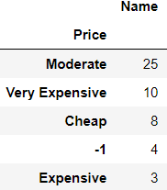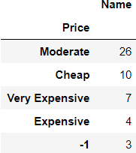

Figure 4 Sydney (left) and Melbourne (right) top 5 restaurant pricing levels

As shown in the table above, half of the restaurants located in the Sydney central area are at a moderate price level. Besides, there are 20% of restaurants (10 out of 49) are marked as 'Very expensive'. There are 4 restaurants lack pricing information thus their pricing levels are marked as '-1'.

As shown in the table above, more than half of the restaurants located in the Melbourne central area are at a moderate price level. Besides, there are 20% of restaurants (10 out of 49) are marked as 'Cheap'. There are 3 restaurants lack pricing information thus their pricing levels are marked as '-1'. The comparison between Sydney and Melbourne restaurant pricing info suggests that the average pricing level in Sydney restaurants are relatively higher.

### Popularity (measured in the number of tips)

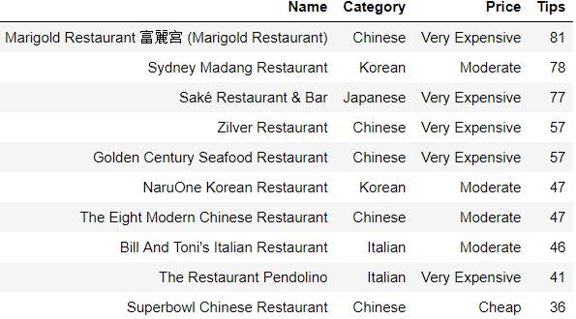

Figure 5 Top 10 commented restaurants in central Sydney

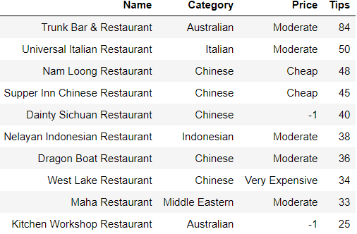

Figure 6 Top 10 commented restaurants in central Melbourne

Figure 5 summarises the most popular (measured in the number of tips) restaurants in the central Sydney. 6 out 10 most popular restaurants are Chinese style, and 9 out 10 most popular restaurants have more than 40 tips.

Figure 6 summarises the most popular (measured in the number of tips) restaurants in the central Melbourne. 5 out 10 most popular restaurants are Chinese style, however, compare to the Sydney results, there are only 5 out 10 most popular restaurants located in central Melbourne have more than 40 tips. The following average tip number also suggests that the restaurants in central Melbourne maybe less popular than those in central Sydney.

## Conclusion

1. Restaurant styles

Sydney and Melbourne have different restaurant styles in the city certral area. Although Chinese restaurant holds a biggest proportion in both areas, there are more Australian style restaurants in Melbourne than in Sydney. Moreover, there are more Italian restaurants in the central Sydney while more Indian restaurants in Melbourne.

1. Restaurant price level

In both cities central areas, 'moderate' restaurants account for around 50%. However, there are a little bit more 'very expensive' restaurants and a little bit fewer 'cheap' restaurants in central Sydney than in central Melbourne. This suggests that the typical meal/dinner expensive may be relatively high in central Sydney.

1. Restaurant popularity measured in the number of tips

While the most commented restaurants in Sydney and Melbourne have similar number of tips, the average number of Sydney restaurant tips is around 30% higher than that in Melbourne (19.76 vs 15.38). This suggests that if measured by Foursquare data users, the restaurants in Sydney maybe more popular than those in Melbourne.

## Appendix

### Sydney restaurants list

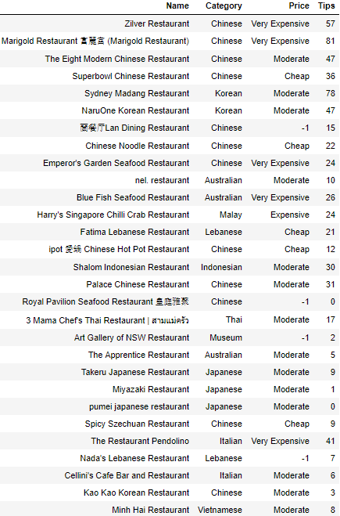

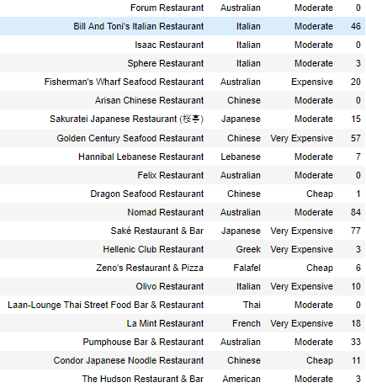

### Melbourne restaurants list

